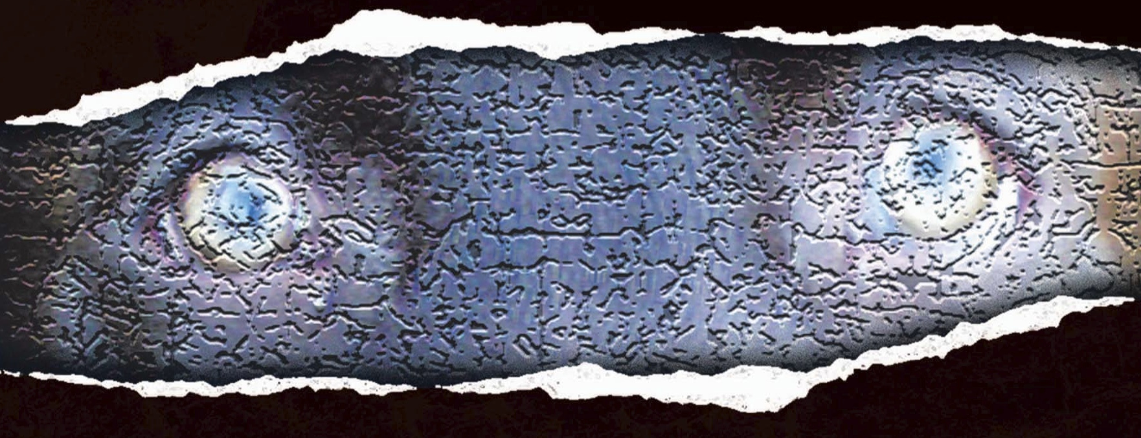
M A R V I N B R O W N

FOR IMMEDIATE RELEASE

ABOUT THE AUTHOR

Marvin Brown is a journalism and English graduate of Ohio’s Bowling Green State University. He is the author of Covet, Jigsaw Man and two award-winning short stories. He resides in Akron, Ohio, with his wife and daughters.
Visit the author’s website at www.marvincbrown.com, and follow the author on Facebook, Twitter (@marvbrown9) and Instagram (marvincbrown).
###

Contact:
Marvin Brown • 344 Hillman Rd., Akron, OH 44312 • 330-472-5473 • marvbrown9@gmail.com

