M A R V I N B R O W N

FOR IMMEDIATE RELEASE

JIGSAW MAN IS HERE

Suspense author’s latest is available in softback & ebook

June 10, 2013 — From the author of Covet comes a mind-bending tale of horror that tests the boundaries of love, forgiveness, evil and death itself.
Caleb Masters thought he’d put his distant past behind him. Years ago, he and five friends committed an unthinkable act. But you never escape your past, a much-older Caleb learns, as he and his friends now face a horrifying and unstoppable force driven by a blinding need for vengeance, a force capable of reaching beyond even death. For Caleb, his friends and all they hold dear, this resurrected nightmare has no end.
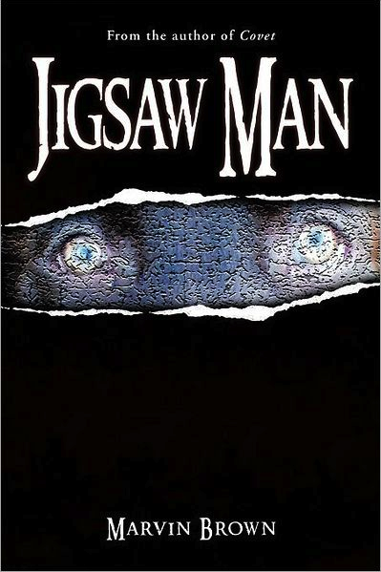
“An intense story about the aftermath of ‘a night of eternal regrets.’ Be prepared for a bloodbath.” — Akron Beacon Journal

Jigsaw Man is now available in softback and ebook formats at multiple online vendors such as amazon.com, barnesandnoble.com, booksamillion.com and alibris.com.
Visit the author’s website at www.marvincbrown.com, and follow the author on Facebook, Twitter (@marvbrown9) and Instagram (marvincbrown).
###
Contact:
Marvin Brown • 344 Hillman Rd., Akron, OH 44312 • 330-472-5473 • marvbrown9@gmail.com

